Bug Tracker

James Campbell

### Table of Contents

Table of Contents

Mission Statement

Database

Features

Trello Link

Wireframe

Schedule

Final Notes

### 

### Mission Statement

This is a app to track issues or bugs, it could also be used as a help desk, or even for feedback. It is built where if someone has an issue they can submit a ticket.

### Database

Table 1

public int Id [pk]

public string Name

public string Content

public DateTimeOffset CreatedUtc

public DateTimeOffset? ModifiedUtc

public DateTimeOffset? CompletedUtc

public bool Complete

public string CompletedBy

public Guid CreatorId

public string CreatedBy

public bool BeingAddressed

public virtual IEnumerable<Attachment> Attachments

public virtual List<Comment> Comments

Table 2

public int Id [pk]

public Guid CreatorId

public string Commentby

public DateTimeOffset CreatedUtc

public DateTimeOffset? ModifiedUtc

public int TicketId [fk]

public virtual Ticket Ticket

public string Content

Table 3

public int Id [pk]

public Guid CreatorId

public string Attachedby

public DateTimeOffset CreatedUtc

public int TicketId [fk]

public virtual Ticket Ticket

public string URL

### Features

|  |  |
| --- | --- |
| Version 1.0 / MVP | Version 2.0 / Stretch Goals |
| * Create a ticket * Comment on a ticket * Add attachment to a ticket * Mark a ticket as being worked on * Mark a ticket as completed * Edit and delete your tickets, comments, and attachments * Admin can edit and delete any tickets, comments, or attachments | * Archive function * Notification function * Make it look really good * Attachment uploads |

### 

### Trello Link

[BugTracker | Trello](https://trello.com/b/KSftAe0z/bugtracker)

Wire Frame

[Bug Tracker - dbdiagram.io](https://dbdiagram.io/d/60d4c7b0dd6a5971481e625d)

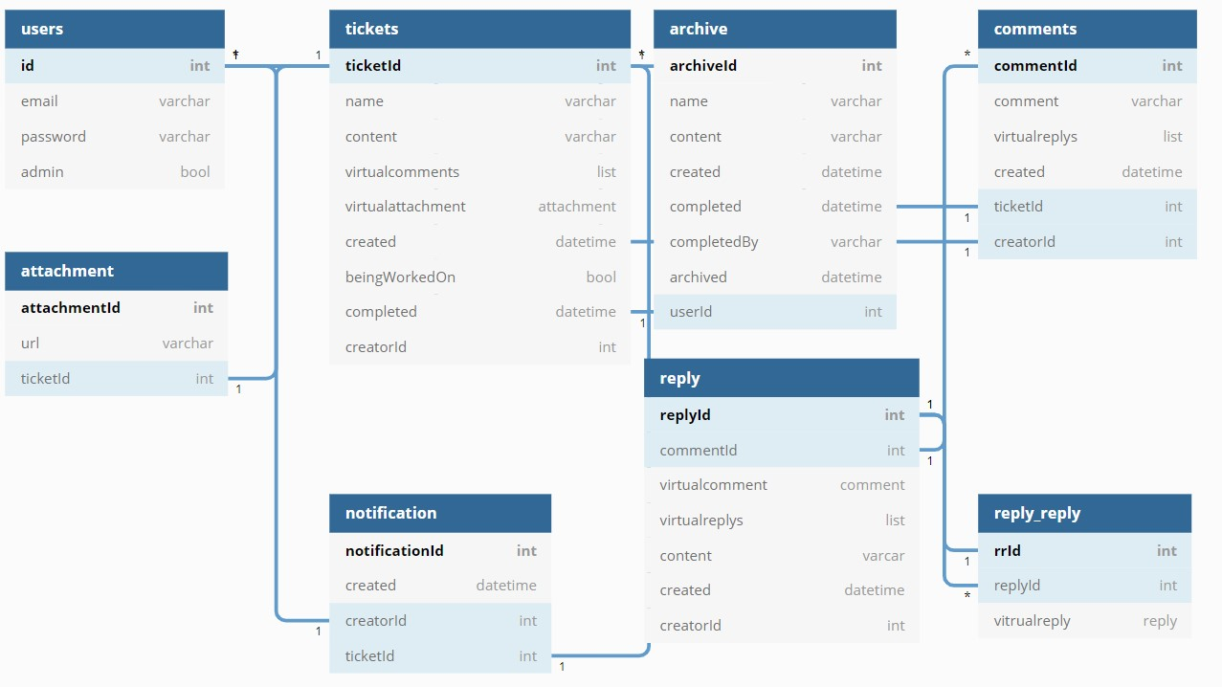

### 

### Schedule

|  |  |  |  |  |  |  |
| --- | --- | --- | --- | --- | --- | --- |
| **Day 1** | **Day 2** | **Day 3** | **Day 4** | **Day 5** | **Day 6** | **Day 7** |
| Planning | Planning | Build base MVC | Start ticket table | Add Attachment table | off | off |
| **Day 8** | **Day 9** | **Day 10** | **Day 11** | **Day 12** | **Day 13** | **Day 14** |
| Holiday | Add comment table | Add User Roles | Get everything to MVP | Work on UI | Off / work on portfolio | Off / work on portfolio |
| **Day 15** | **Day 16** | **Day 17** | **Day 18** |  |  |  |
| UI and Strech goals | UI and Strech goals  Testing | Testing and deploy to Azure | Turn In |  |  |  |